Index.

1. Frameworks for node.
2. Electron: short introduction.
3. Creation of executables with electron.

In this topic we will quickly see what we intend to create during this course: desktop applications with graphical user interfaces using web technologies, specifically javascript, node and electron. We will create an example but we do not go into depth in many concepts and many things will remain in the air. We will see them in other topics with more detail and doubts will be cleared.

1. Frameworks for javascript.

A framework is a set of software (libraries, functions, modules, ...) that works with a specific programming language. There are frameworks for java, c, etc. Of course also for node. It is convenient to clarify that everything can be done without framewoks and start from scratch, but they allow programming to be more productive.
Javascsript has a multitude of framewoks that facilitate the creation of applications of many types. Some very used:

- Express: allows you to create web servers and services.
- Ionic: to create hybrid mobile applications.
- Electron: to develop desktop applications that can run on windows, OS or linux.
- Client-side framework: to design the client part of a web application, there are many: angular, vue, etc.

Of course with node all these frameworks can be used.
Many of these framewoks can work together, for example the MEAN stack, acronym for mongoDb-express-angular-node, became popular a while ago. With electron we can also use express and angular.

2. Electron: short introduction.

What Electron does is wrap applications developed with web technologies so that they can be run as a cross-platform desktop app. It is important to note that almost everything that we will do in this course could be executed without electron and would be normal web applications.

Electron is installed as a module using npm. Like all node modules, to work with electron we can use two ways: install it globally on the computer or install it locally in the folder of a node project (it is installed in the node-modules folder. Let's install it locally, inside our project folder the command is used:

npm install electron

When we use this way of installing it electron is not installed on the computer globally, but it is installed inside the folder of our project, specifically in the node-modules subdirectory. Also the above command creates a development dependency entry in the project package.json:

"Dependencies": "electron xxx"

Working locally has multiple benefits. One of them is that each of our projects may be made in a different version of electron. Also, if we want to take our node project from one PC to another, it is best to copy the entire project except the node-modules folder (which will tend to be large). To create the node-modules folder again we will use, from the project folder, the command: npm install

3. Creation of executables with electron.

We are going to create an executable with node and electron, a "hello world". The first thing we will do is download a minimal project with electron from github:

https://github.com/electron/electron-quick-start

We download it in zip:

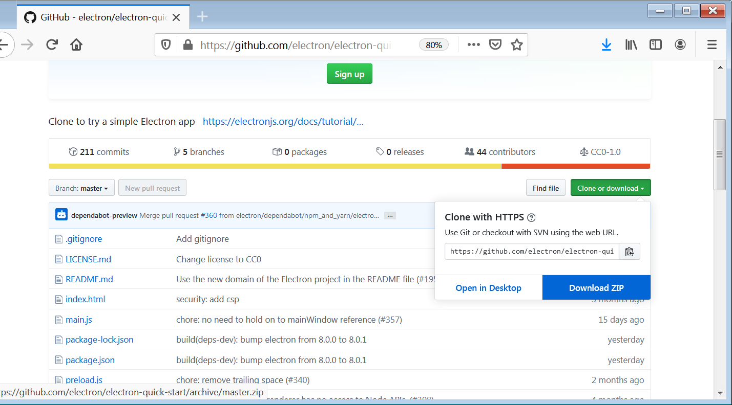

We unzip it and open the folder with code:

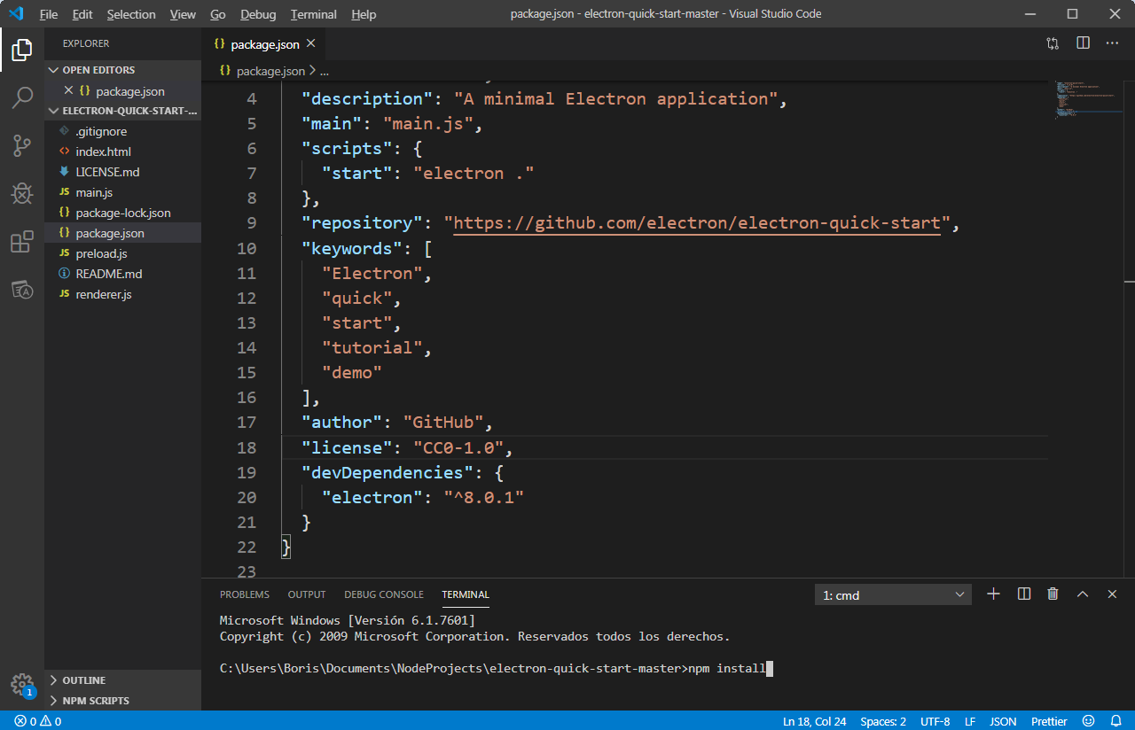

It has created multiple files. For now we will not go into each of them, we will see them carefully in later topics. If we are going to look at package.json. As you can see, an entry for electron is created as a development dependency. If we run the npm install command, it will install it in node-modules. It also has a start entry to run the project, we do it with npm start:

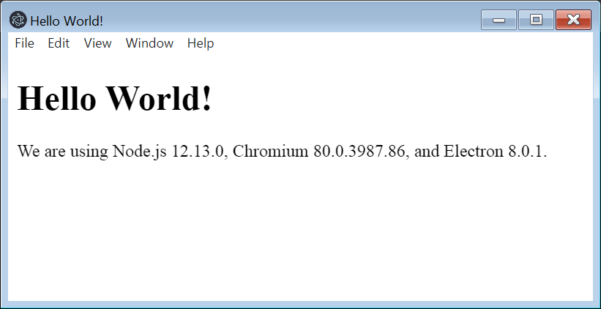

To generate an executable we will use electron-packager, installing it as a development dependency:

npm install electron-packager –save-dev

Besides installing the module create an entry in package.json:

"electron-packager": "^ 14.2.1"

Now we will include an entry in to run this package from npm:

"scripts": {
"start": "electron.",
"build": "electron-packager."
},

(To be able to run electron-packager on windows it is necessary to have installed .net framework 4.5 or higher and powershell 3 or higher)

We run it with:

npm run build

This will create a directory depending on the architecture and operating system, in my case:

electron-quick-start-win32-x64

Inside we can find the executable:

electron-quick-start.exe

